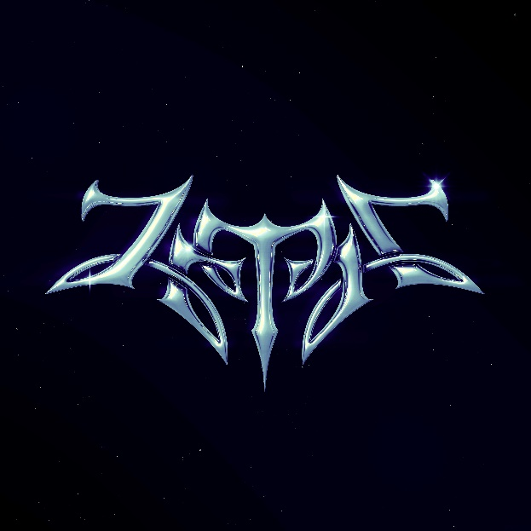
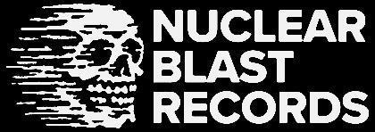

ZETRA
Zetra

Release Date: September 13th, 2024

Line up: | ZETRA online:
ZETRA | vocals, guitars, synths, drum programming | instagram.com/wearezetra  facebook.com/wearezetra  twitter.com/wearezetra
Spectres have been stirring in the shadows for years now. Dark eyes watching from pallid faces. Siren songs calling to lost souls. In the blackest corners of the UK underground, a name whispered relentlessly amongst the faithful, first with curiosity, then soul-shuddering awe: Zetra.

“Zetra is another place, on another plane,” reads the scrawl on a tattered document, illuminated by both candlelight and the crackling static of ancient CRT screens, deep in the shadowy inner sanctum of Britain’s most mysterious band. “It was built on truth. Fatalistic truth. Bad things happen, but they happen for a reason. Catastrophically, however, Zetra has been infected by the poison of falsehood, eroded – as with acid – at its very foundations. Now, a journey into the grey between truth and lies. A search for salvation from the deceptions that might strangle us all...”

Two figures lead the way. These are The Wanderers. Those who have crossed their path have already called them by many names: The Flighty and The Heavy; The Dagger and The Staff; Vocals and Synthesiser; Beauty and The Beast. Individually and collectively, though, they too are Zetra.
“And as long as there is a shard of Zetra somewhere in the universe, Zetra can be wholly rebuilt…”

Zetra is also the title of their striking debut LP. Ten tracks whose indefinable blend of shimmering shoegaze and pulsating goth-metal work deep beneath the skin, it is a masterclass in intimate dark romanticism and sweeping elemental beauty. It could be seen as a reaction to the geography of a strange new world, but also to the jagged topography of the human psyche itself. Is it a manifesto? A roadmap? A riddle waiting to be solved? Profound pleasure lies in peeling back its many layers.

“They are observers of different events, different times, different themes,” The Document teases at threads of mystique, generating more fascination than obfuscation. “But Zetra are beyond your reckoning...”

Initially, its songs feel like reactions to the jaded machinations and contradictions of humankind. Dramatic opener ‘Suffer Eternally’, for instance, is an existential reckoning on the perpetual pain of life on earth into which Zetra have been drawn: “Breathe in fallout / It’s over / We were born to suffer / Eternally alone at the altar...”. ‘Sacrifice’, meanwhile, digs into the delicate balance between trading things away in our hour of need and dealing with those losses down the line. Its arch perspective feels often as if Superman’s Kal-El or Transformers’ Optimus Prime had emerged from the Stygian darkness between stars, armed not with muscle or metal, but only spellbinding sound.

Travelling alone, armed only with synths, guitar and drum-machine to compose, The Wanderers’ music could sound skeletal. Instead its early metallic bones have been fleshed-out with the electronic new-wave of Gary Numan and Pet Shop Boys and dreamy, droning guitars that hark to heroes like Slowdive and Sonic Youth as well as dark contemporaries Deafheaven and Alcest. As harsh as the truths with which they deal may be, these songs deliver beguiling brilliance.

“There is a beauty in the discord,” The Document goes on. “It is crucial to acknowledge that. Deception can become an addictive poison. Unpredictability can be fuel for great adventure…”

Indeed, the album’s later tracks embrace life’s chaos, often seeded from a greater moral ambiguity and rejection of the notion of predestined fate in favour of free will. Shimmering highlight ‘The Mirror’ asks whether it is the observer or their reflection truly in control: “The day will not be forced / Who is free, you control me…”. ‘Shatter The Mountain’s metaphorical world-breaking – “Give up your final hope / Out in the wastelands / There’s nothing for you…” – contrasts with Gaia’s steady-handed portrait of a species burning the ground on which they exist: “Gaia’s on fire / Ignite her!”. ‘Starfall’s celestial glow is counterpointed by the mercurial ‘Moonfall’. Even the drained euphoria of intoxicating final track ‘Miracle’ feels like a bittersweet riposte to the album’s caustic beginning.

“The road has led to more questions than answers. Even in the grey, though, hope is never lost…”

Acolytes to spread the word of Zetra aren’t hard to find. British ‘contemporaries’ like Burner and Wallowing, Celestial Sanctuary and Employed To Serve have been dementedly singing their praises as far back as they can remember. Tours with the heavyweight likes of Creeper and Godflesh, VV and SKYND have taken their once-subterranean sounds into the spotlight. Unto Others’ Gabriel Franco (‘Moonfall’), Svalbard’s Serena Cherry (‘Starfall’) and Sólveig Matthildur Kristjánsdóttir from Iceland’s Kælan Mikla (‘Shatter The Mountain’) even crop up amongst these recordings, dissolving into the cult of Zetra themselves. But none are as important as the legions of fans Zetra are yet to reach with a dark gospel still unpicking all manner of psychological knots and existential truths.

“The door has only just opened…” The Document concludes with a mesmerising promise that devotees won’t be able to help but follow into the lengthening shadow. “These recordings aren’t the end of Zetra’s journey. They are but The Beginning. So listen closely to find where this dark path leads...”

